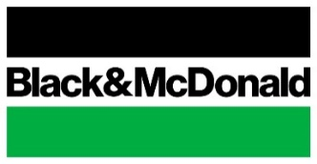
Memo
To: RVP, Division Managers, HSE, National Procurement

From: Anthony Di Gianni, Corporate Director of Health, Safety & Environment
Wael Safwat, Director, National Procurement
Date: March 17, 2020
Re: Securing PPE items by leveraging both local and national suppliers
Good afternoon,

In light of the evolving situation of COVID-19 and the ongoing disruption of PPE supply chain, please consider the following:

- Ensure the availability of the following PPE items at least for 4-6 weeks

  - N95 Mask (no exhalation valve)
  - Respirator Clean Kit Dry Soap
  - Respirator Cleaning Wipes
  - Monkey Wrench Gloves (Nitrile gloves)
  - Individual Hand Sanitizer Bottles
  - Hand Sanitizer Refills
  - Individual Hand Soap
  - Hand Soap Refill (4L)
  - Clorox Versasure Cleaner Disinfectant Wipes
  - Georgia-Pacific® enMotion® High Capacity Touchless Roll Towel
  - Toilet Paper
  - Computer Safe Disinfectant Wipes

- Engage with your regional procurement team to reach out to both local and national suppliers to secure minimum stock. It’s advisable to approach multiple suppliers. Should you have any challenges to receive support from your local suppliers, please engage National Procurement who are available to leverage national suppliers were possible.

Corporate HSE in collaboration with National procurement was able to secure a centralized minimum stock at CVD. The objective of this stock is to support various offices in case of shortage while waiting to receive their own shipments from the suppliers.

Should you have any questions related to;
- Which PPE Items to be orders and the minimum stock level, please consult your Regional HSE Advisor.
- Suppliers, please approach your regional procurement team and/or National Procurement Team

Thanks for your collaboration.

